Zee,wants to know the customers who have hired laptops in May 2020 and the amount fetched from that customer. Write a query to display rental id,customer id,laptop id,amount, modified amount(right pad amount with * in length of 10 for of all laptops hired in  May 2020 sorted by rental id. Ensure that query output displays amount only if it is greater than 7000. provide an alias for right padded column as modified amount.

 Design rules:

1.Display the laptops taken in May 2020 with amount exceeding 7000/-

2.Do Not Change the name of the column. Please use as per the design rules

3.Order of the output columns: rental_id,cust id,laptop_id,amount,modified amount

4.Sort the output in Ascending order based on rental_id.

Please refer to the schema:

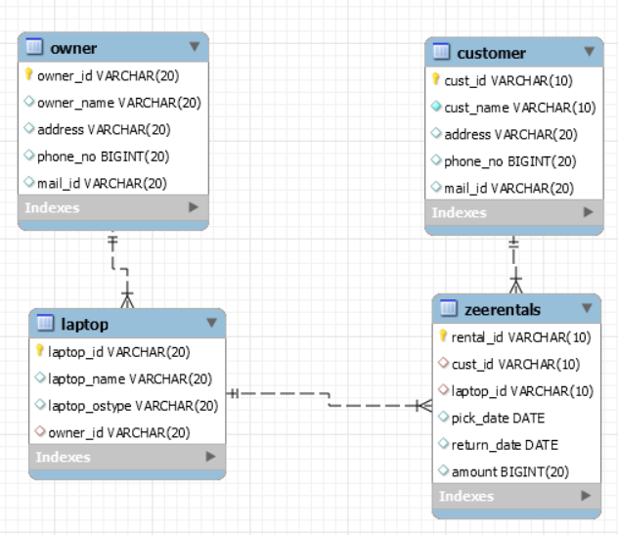

SELECT rental_id, cust_id, laptop_id, amount

FROM zeerentals

Where pick_date = “MAY 2020” and amount > 7000

Order by rental_id